Sheet 4

Computing algorithms
Q1:
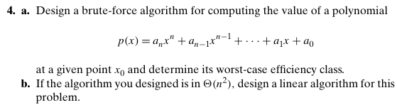
Q2: Sort the list E,X,A,M,P,L,E in alphabetical order by selection sort and bubble sort
Q3: State if the selection sort and bubble sort are stable and in-place.
Q4:
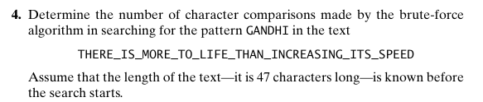
Q5:
